Lesson 3 Demo 5: Log in to a Registry

This section will guide you to:

* Log in to a local Docker registry

**Step 1:** Log in to a local Docker registry

* Create a password file with a username and password used for logging in to the local registry

*sudo docker run --entrypoint htpasswd httpd:2.4 -Bbn USERNAME PASWORD > auth/httpd.htpasswd*

**Note:** Replace USERNAME and PASSWORD with your desired username and password respectively for docker login.

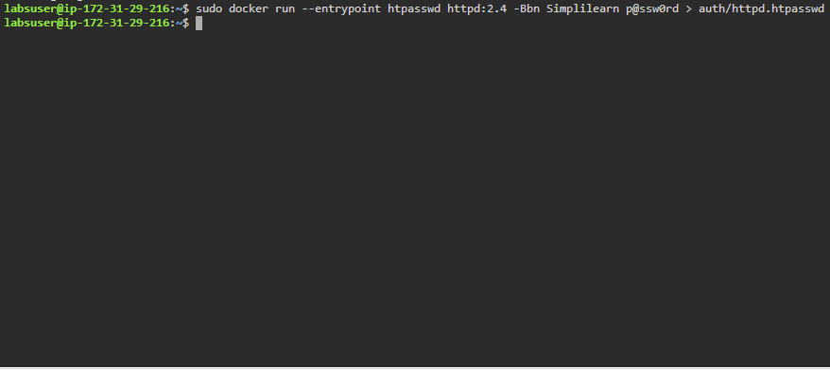

**Note:** In case you get an error “No such file or directory”, you can install the apache2- utils package by executing the following command **sudo apt-get install apache2-utils.** Then find the path of htpasswd using the command **whereis htpasswd.** Next, you will have to change the path *auth/httpd.htpasswd* to thepath shown after executing the whereis htpasswd command.

* Use the following command to login to the local registry created in the previous demo (Demo 3.4):

*sudo docker login localhost:5000*

